ILMA ERP

Super Admin Portal
Developer Handout Edition
Full SaaS foundation • Multi-vendor ready • AI-enabled • Simple by design

Purpose. A shared implementation blueprint for product, design, backend, frontend, QA, DevOps, and AI engineers. Start by managing ILMA Education ERP for Al-Mantiq while creating a clean foundation for future products, industries, and third-party vendors.
Architecture reference, not a final technology prescription.

How to Use This Handout
Use this as a baseline for discovery, system design, engineering tickets, and acceptance testing. Confirm the existing ILMA stack, database, authentication, hosting, and operational processes before selecting specific technologies.
- Build the first production release for Al-Mantiq and ILMA ERP only.
- Design the data model around organizations, products, memberships, plans, entitlements, invitations, and audit events.
- Keep the interface calm and task-focused: one overview, clear navigation, searchable tables, concise statuses, and confirmation for risky actions.
- Keep the implementation modular, but do not split everything into microservices at the start.
- Treat vendor management as a planned capability, not a reason to delay the ILMA release.
- AI assists users; it never becomes an alternate authorization system.

1. Product Requirements and Scope

1.1 First-release capabilities
- Central overview of ILMA institutes, access status, subscriptions, invitations, and operational alerts.
- Create and manage customer/institute organizations and branches/campuses.
- Invite institute administrators with secure, expiring invitations; track pending, accepted, expired, and revoked states.
- Grant, change, suspend, and revoke access with backend authorization and audit logging.
- Manage product assignment, plan/subscription status, renewals, and feature entitlements.
- Show real-time or clearly timestamped customer analytics: counts, activity indicators, plan distribution, onboarding, and renewal status.
- Maintain billing/invoice records and track internal expenses as a separate finance function.
- Manage internal staff, role permissions, support cases, follow-ups, and escalations.
- Track integration and system health where the underlying services provide reliable status.
- Keep searchable audit history for privileged actions.
- Provide an elegant, responsive, low-clutter UI with sensible defaults and progressive disclosure.

1.2 Future-phase capabilities
- Additional Al-Mantiq products and industry modules.
- Vendor registry, onboarding, approval, product registration, isolated vendor dashboard and vendor-specific roles.
- Vendor fees/commissions and settlement if the commercial model requires them.
- Public vendor marketplace and self-service publishing.
- Advanced AI workflows and autonomous operations.

1.3 Out of scope for initial release
- Unrestricted ability to modify data inside every connected vendor application.
- Automatic revenue sharing before legal/commercial terms and reconciliation rules are defined.
- Complex microservice infrastructure without demonstrated need.
- AI making access, suspension, payment, or financial decisions without policy checks and human approval.

2. UX and Navigation Blueprint
Navigation | Primary job | Priority
Overview | See health, exceptions, and customer metrics | Must
Institutes / Customers | Search, onboard, edit, suspend, view profile | Must
Access & Invitations | Invite admins; track, expire, revoke access | Must
Products & Plans | ILMA product, plans, entitlements | Must
Subscriptions & Billing | Plan state, invoices, renewal/payment status | Must
Expenses | Internal expense tracking or accounting link | Validate process
Analytics | Customer growth, usage, renewals, onboarding | Basic must
Support | Cases, follow-ups, escalations | Should
Team & Roles | Internal accounts and permissions | Must
Integrations & Health | Integration status and alerts | Basic
Audit Log | Who changed what and when | Must
Vendors | Hidden/disabled until Phase 3 | Future
Settings | Platform configuration and notifications | Basic

UI principles
- Show common actions first; avoid putting every future capability on the home screen.
- Use consistent status names and do not rely on color alone.
- Use a table → organization profile → tabs pattern for overview, subscription, access, support, and audit.
- Require confirmation and a reason for suspension, revocation, role changes, or financial adjustments.
- Provide useful empty states, validation messages, keyboard navigation, readable contrast, and responsive layouts.

3. Logical Architecture
Recommended starting point: a modular monolith with clear internal modules and APIs. Deploy as one application initially if that fits the existing team and hosting; separate components only when reliability, scaling, security, or ownership justifies it.
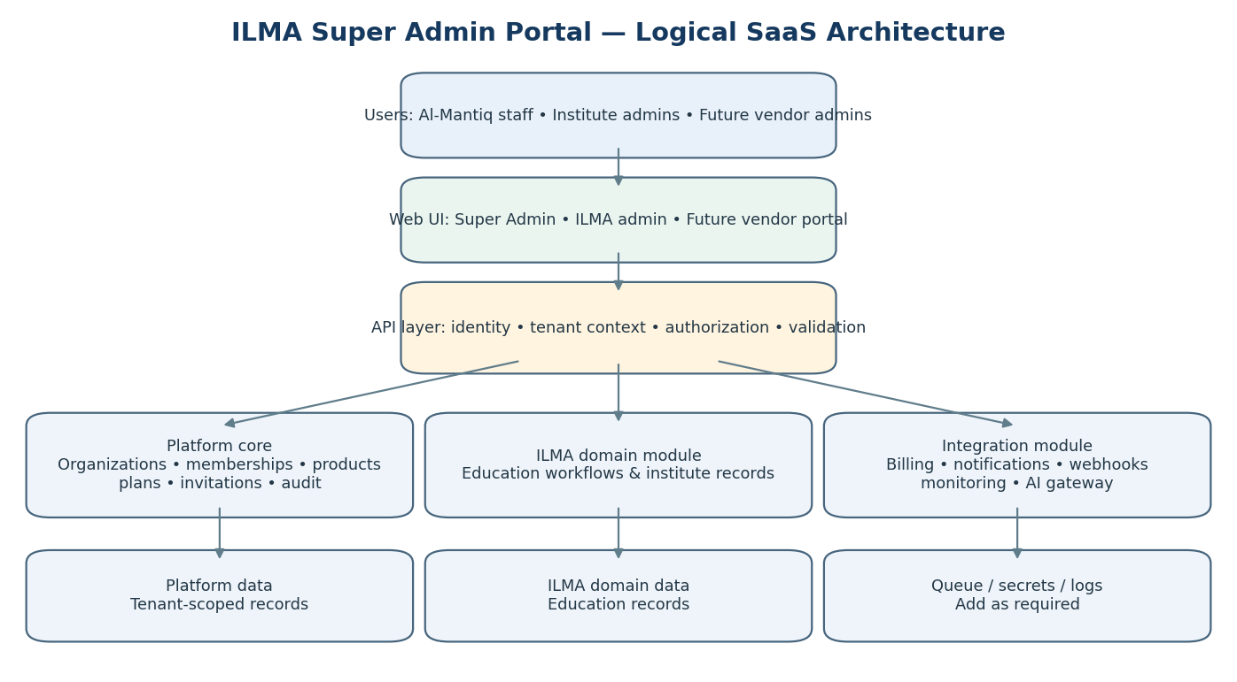
Figure 1. Logical SaaS architecture. Boxes represent logical boundaries, not a requirement for separate servers.
Module | Responsibility | Implementation note
Identity & Access | Authentication, sessions, roles, memberships, invitations | Reuse existing identity provider if suitable; enforce permissions server-side.
Organization/Tenant | Organizations, branches, tenant lifecycle | Organization is the main customer boundary.
Product Catalogue | Products, modules, plans, entitlements | ILMA is the first enabled product.
Provisioning | Enable product for tenant and initialize settings | Must be idempotent and auditable.
Subscriptions & Billing | Subscription state, invoices, payments, renewals | Keep invoice/payment state separate from access entitlement.
Analytics | Operational metrics and approved aggregates | Define metric meaning and freshness.
Support | Cases, ownership, escalation, approved support access | No unrestricted impersonation.
Integrations | External systems, webhook delivery, credential references | Secrets live in a secrets manager.
Audit & Security | Append-only event history for privileged actions | Restrict log access and prevent ordinary edits.
AI Gateway | Intent, retrieval, summarization, safe tool proposals | AI calls authorized APIs; no unrestricted database access.

3.1 Deployment principles
- Start with one codebase and explicit module boundaries; avoid premature microservices.
- Use a relational database for transactional records unless the existing ILMA stack imposes a strong constraint.
- Use background jobs for email, webhooks, analytics refreshes, and long-running provisioning when needed.
- Implement centralized logs, error tracking, backups, and health checks before expanding to vendors.
- Choose technology after inspecting ILMA’s existing application, auth, hosting, and data model; do not rewrite stable components without a clear benefit.

4. Data Model and ERDs
These ERDs are logical starting points. Adapt names and cardinalities to the current ILMA database and actual billing rules. Use stable IDs, timestamps, lifecycle statuses, foreign keys, and tenant-scoped authorization.
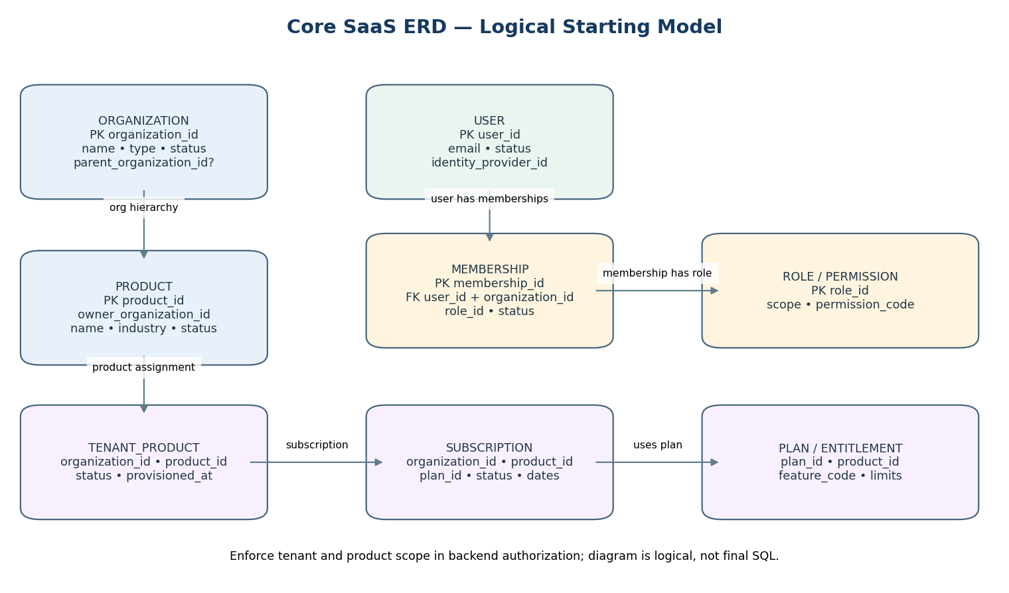
Figure 2. Core SaaS ERD: organization, user, membership, role, product, tenant assignment, subscription, plan.

4.1 Entity catalogue
Entity | Illustrative fields | Rules / notes
Organization | organization_id, name, type, status, parent_organization_id | Represents Al-Mantiq, a future vendor, or a customer/institute.
Branch | branch_id, organization_id, name, status | Add if ILMA needs branch/campus structure.
User | user_id, email, status, identity_provider_id | Global identity; do not duplicate one user per organization.
Membership | membership_id, user_id, organization_id, role_id, status | Join record: one user can belong to multiple organizations.
Role / Permission | role_id, scope_type, permission_code | Explicit permissions are more flexible than hard-coded role names.
Product | product_id, owner_organization_id, name, industry, status | ILMA Education ERP is first product.
TenantProduct | id, organization_id, product_id, status | Records that an organization is provisioned for a product.
Plan / Entitlement | plan_id, product_id; feature_code, limit_value | Features and limits available under a plan.
Subscription | subscription_id, organization_id, product_id, plan_id, status, dates | Plan must belong to the same product; state transitions validated.
Invitation | invitation_id, email, org/product/role, token_hash, expires_at, status | Store token hash, not raw token; expiry and revocation supported.
Invoice / Payment | invoice_id, subscription_id, amount, currency, status; payment reference | Use fixed-point/decimal money and explicit currency.
Expense | expense_id, category, amount, currency, incurred_at, status | Internal expenses are distinct from customer invoices.
SupportCase | case_id, organization_id, product_id, priority, status, owner | Limit sensitive information in case notes.
Integration | integration_id, owner_org_id, product_id, scopes, status, secret_ref | Secret material stored outside normal DB tables.
AuditEvent | actor, action, target, timestamp, reason, metadata | Never log passwords, tokens, or unnecessary sensitive data.
AIRequestLog | actor, tenant scope, purpose, outcome, approval_id | Minimize prompt storage; log governance metadata.

4.2 Operational ERD
Implementation relationships for operational records:
- Invitation is scoped to an organization, product, role, intended email, expiry, and status.
- Invoice belongs to a subscription; payment events should be idempotent and reconciled.
- Support cases belong to an organization and product; support access is separately authorized.
- Integration belongs to a product/owner organization and records scopes and a secret reference, not the secret itself.
- AI request log records actor, purpose, tenant scope, tool calls, outcome, and approval metadata.

4.3 Relationships to enforce
- Organization 1→many branches, memberships, product assignments, subscriptions, and support cases.
- User many↔many organizations through Membership; membership carries role and status.
- Product 1→many plans and tenant-product assignments; product ownership is explicit.
- Subscription belongs to one customer organization and product; the selected plan must belong to that product.
- Vendor-owned products must be owned by a vendor organization and approved before activation.
- Every tenant-owned record must be checked against authenticated tenant context at the service/API layer.

4.4 Constraints and indexes
- Foreign keys for organization/product/plan relationships and uniqueness rules for assignments where required.
- Indexes on organization_id, product_id, status, created_at, renewal date, and common search fields.
- Idempotency keys for provisioning, payment callbacks, and webhook processing.
- Protect sensitive state transitions with transactions and concurrency checks.
- Use soft deletion only where appropriate; use explicit lifecycle states for suspension/offboarding.

5. Flow Diagrams and State Transitions
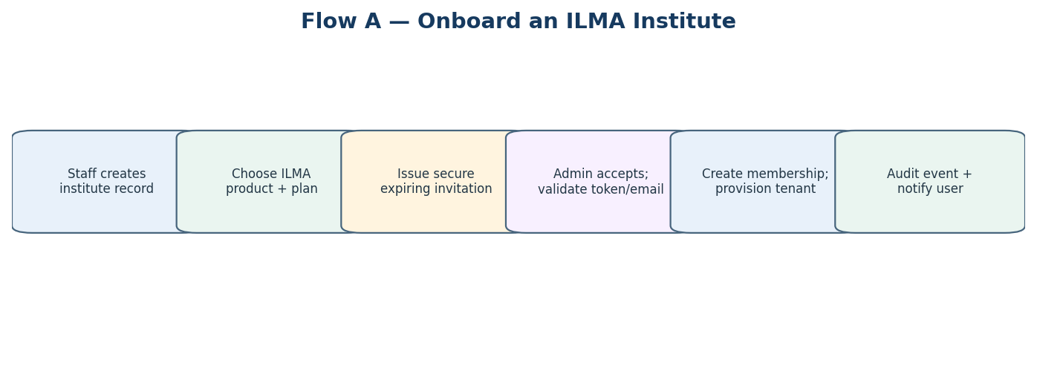
Figure 3. Institute onboarding.

5.1 Onboarding acceptance criteria
- Only authorized staff can create an organization and issue invitations.
- Invite links expire and can be revoked; token values are never logged.
- Acceptance validates token, expiry, intended email, organization, product, and role.
- Provisioning is idempotent: retrying must not create duplicate assignments.
- Each state change is audited and the user receives a clear success/error message.
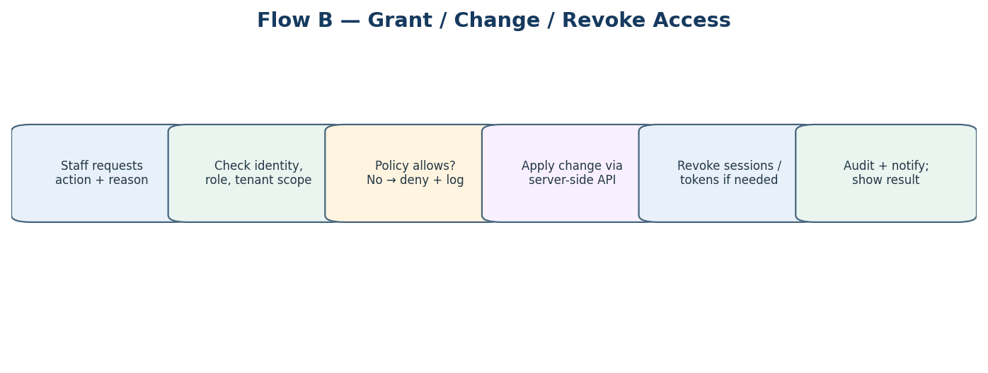
Figure 4. Grant, change, suspend, or revoke access.
- Authorization is checked server-side for every action, including direct API calls.
- Suspension/revocation invalidates relevant sessions, refresh tokens, API tokens, or memberships as appropriate.
- High-impact actions require confirmation and a reason; preserve audit evidence.

5.2 Subscription lifecycle
TRIAL → ACTIVE → RENEWAL DUE → ACTIVE
│ │
├─ expires └─ payment fails → GRACE PERIOD → ACTIVE
│ └──→ PAST DUE / SUSPENDED
└────────────────────────────────────────→ EXPIRED
Other explicit states may include CANCELLED and TERMINATED.
Define allowed transitions, actor, trigger, grace period, notifications and access behavior.
Invoice state and subscription state must be separate fields.
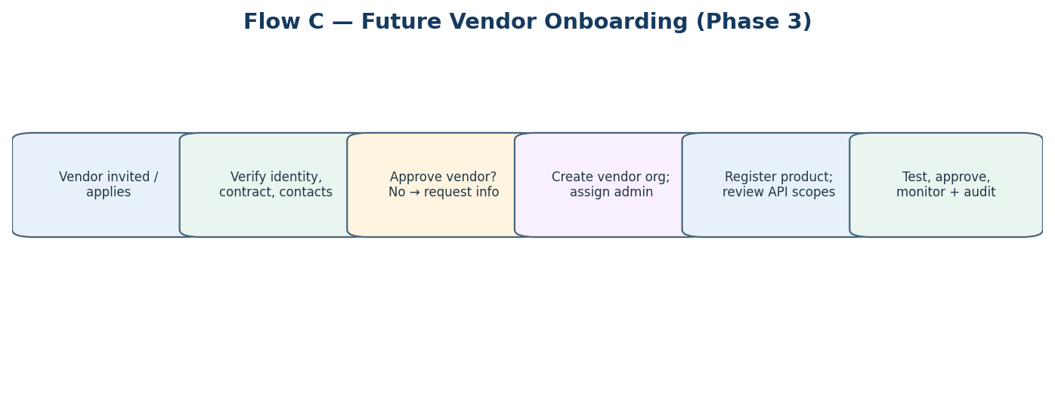
Figure 5. Future vendor onboarding (Phase 3).
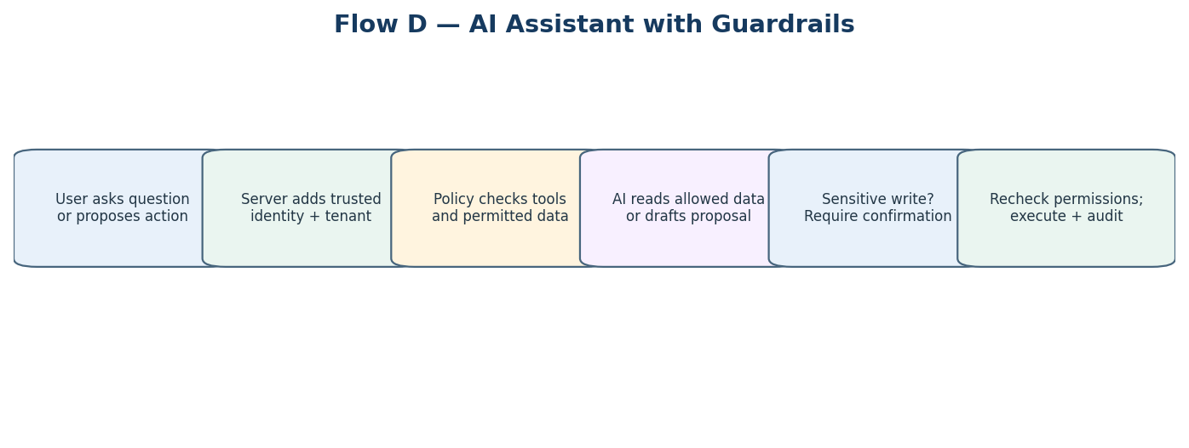
Figure 6. AI assistant uses the same authorization model as the UI and API.

6. AI Features: Useful, Bounded, Auditable
Introduce AI in small, measurable steps. Prefer read-only assistance first; security, billing, access and tenant-isolation rules remain deterministic application logic.
AI feature | Value | Guardrails | Phase
Natural-language analytics | Ask how many active institutes renew this month | Approved metrics only; show date range/filters; never invent numbers | 1.5
Support case summary | Summarize case history and suggest next steps | Only cases user can access; human decides resolution | 1.5
Onboarding copilot | Guide staff through required fields and invite setup | Suggestions are reviewed before saving | 1.5
Search assistant | Find institute, invoice, or case in natural language | Same tenant scope and permissions as normal search | 1.5
Anomaly/renewal signals | Flag unusual failures or overdue work | Explain signal and data window; flag is not a verdict | 2
Vendor integration assistant | Explain setup steps and API errors | Vendor sees only its own logs/docs; never reveal secrets | 3
AI action proposal | Draft a plan change or suspension | Human confirmation and fresh permission check before execution | Later

6.1 AI safety requirements
- Tenant scope and user identity come from trusted server-side context, not prompt text.
- Use an allowlist of tools/endpoints; no arbitrary database access or unrestricted SQL.
- Re-check authorization when an AI-proposed action is executed.
- Require explicit confirmation for suspend/revoke, role changes, subscription changes, invoice adjustments, and vendor status changes.
- Minimize data sent to the model; redact secrets and unnecessary personal data.
- Log purpose, authorized scope, tools invoked, outcome and approvals without storing sensitive prompts unnecessarily.
- Show source records/filters for analytics and uncertainty where relevant.
- Provide an AI-off fallback; the portal must work if the AI provider is unavailable.
- Define model-provider data handling, retention, and permitted use before sending customer data.

7. Security and Multi-Tenant Rules
- Authentication proves identity; authorization determines permitted actions.
- Every API request establishes caller, active organization/tenant, product, and permission.
- Never rely on frontend hiding or client-supplied organization IDs alone.
- Test cross-tenant leakage across list/detail/export APIs, background jobs, analytics, webhooks, and AI tools.
- Use least privilege for Al-Mantiq staff, vendor admins, and institute admins; protect the platform super-admin role.
- Use MFA for privileged accounts where available; rate-limit login, invite acceptance, AI, exports, and sensitive operations.
- Store secrets in a secrets manager; rotate/revoke credentials and redact logs.
- Use TLS, encryption at rest where supported, tested backups, and documented recovery.
- Define retention, data export/deletion, incident response, and offboarding procedures.

8. Multi-Vendor SaaS Foundation
The initial portal is Al-Mantiq-only. Keep the domain model extensible, but do not activate vendor screens or complex marketplace behavior until the core ILMA platform is stable.
Al-Mantiq Platform
├─ Al-Mantiq products (starting with ILMA Education ERP)
│ └─ Customer organizations / institutes
│ └─ Branches, users, product-specific records
└─ Future vendor organizations
└─ Vendor-owned products / integrations
└─ Authorized customer organizations

8.1 Future vendor controls
- Global Vendor Registry: identity, verification, contract state, admin users, products, and lifecycle status.
- Vendor-specific dashboard with access only to its own products, permitted customer summaries, integrations, and billing records.
- Product registration and security/integration review before activation.
- Scoped API credentials, rotation/revocation, health checks, and audit history.
- Fees/commissions only after contract, refund, tax, currency, settlement, and reconciliation rules are defined.
- Support/compliance cases, escalation paths, and controlled offboarding.
Boundary: centralize common platform functions. Deep vendor-specific actions require documented APIs and explicit authorization. Vendor/customer data must remain isolated; support access should be scoped, time-limited, reason-based, and audited.

9. Illustrative API Surface
These are examples; follow existing ILMA API conventions where they already work.
POST /api/v1/organizations
GET /api/v1/organizations?status=active&product=ilma
GET /api/v1/organizations/{organizationId}
PATCH /api/v1/organizations/{organizationId}
POST /api/v1/organizations/{organizationId}/invitations
POST /api/v1/invitations/{invitationId}/revoke
POST /api/v1/organizations/{organizationId}/products/{productId}/provision
GET /api/v1/subscriptions?organizationId=...
POST /api/v1/subscriptions/{subscriptionId}/change-plan
POST /api/v1/access/{membershipId}/suspend
POST /api/v1/access/{membershipId}/revoke
GET /api/v1/analytics/overview
GET /api/v1/audit-events?targetId=...
POST /api/v1/support-cases
GET /api/v1/integrations/{integrationId}/health
Future, disabled until Phase 3:
POST /api/v1/vendors
POST /api/v1/vendors/{vendorId}/products
POST /api/v1/vendors/{vendorId}/products/{productId}/approve

9.1 API requirements
- Consistent response envelopes and machine-readable error codes.
- Input validation and object-level authorization for every resource.
- Pagination, filtering, sorting, and explicit export permissions.
- Idempotency keys for provisioning and payment-related retries.
- Webhook signatures, retries, and idempotent event handling where webhooks are used.
- Never return secret values after initial creation; return safe metadata only.

10. Analytics, Billing and Expenses
Metric | Definition to agree | Notes
Total institutes | Customer organizations assigned to ILMA | Exclude vendor orgs and internal test tenants.
Active institutes | Organizations with active ILMA assignment and allowed access | Define grace-period treatment.
Pending invitations | Sent but not accepted, expired, or revoked | Show age; allow resend/revoke.
Renewals due | Subscriptions renewing in selected window | Always display date window.
Past-due invoices | Unpaid after due date | Invoice state differs from subscription state.
New customers | First-time ILMA activations in a period | Define which timestamp counts.
Support backlog | Open cases by priority and age | Source case status remains authoritative.
- Keep customer invoices/revenue and internal expenses as separate records and reports.
- Store amount, currency, dates, status, and external references.
- Define who invoices the customer before payment automation.
- Do not store raw card data; use a payment provider if online payments are introduced.
- Commission calculations later must define gross/net basis, refunds, taxes, currency conversion, settlement, and reconciliation.

11. Non-Functional Requirements
Area | Baseline
Usability | Common tasks discoverable; consistent forms, filters, statuses, confirmations.
Performance | Set targets after measurement; paginate tables and avoid expensive dashboard queries on every request.
Availability | Agree service target; expose health and actionable errors.
Security | Threat model, least privilege, tenant-isolation tests, secret management, audit, patching.
Maintainability | Module boundaries, reviews, API contracts, migrations, tests, runbooks.
Observability | Structured logs, correlation IDs, metrics, error tracking, health checks, alert ownership.
Accessibility | Keyboard support, labels, contrast, focus states, understandable errors.
Recovery | Backups, restore tests, recovery objectives, documented incident procedure.
Privacy | Data minimization, retention, controlled exports, approved AI processing.

12. Engineering Work Plan

Sprint 0 — Discovery and safeguards
- Inspect ILMA stack, schema, authentication, deployment and hosting.
- Confirm institute/branch concepts and data ownership.
- Map invitation, access, subscription, billing and expense workflows.
- Agree roles, permission matrix, audit events, retention and backups.

Sprint 1 — Platform foundation
- Implement or map organization, membership, role/permission and product records.
- Implement tenant context and server-side authorization middleware.
- Add audit-event service and cross-tenant tests.
- Create internal portal shell and navigation.

Sprint 2 — ILMA customer operations
- Institute registry, branches, status and search.
- Invitation lifecycle and idempotent provisioning.
- Grant/change/suspend/revoke access.
- Customer profile with product and access summary.

Sprint 3 — Plans, billing, analytics
- Plan and entitlement catalogue.
- Subscription lifecycle and renewal view.
- Invoice/payment integration or controlled manual workflow.
- Overview metrics with documented definitions.
- Add expense tracking after ownership/process is confirmed.

Sprint 4 — Support, polish, release
- Support cases and escalation.
- Audit search and operational alerts.
- Responsive UI, empty states, accessibility and errors.
- Backup/restore test, security test, migration rehearsal, UAT and launch checklist.

After core release
- Add AI read-only analytics and case summarization behind feature flags.
- Add more Al-Mantiq products using product registry and entitlements.
- Activate vendor onboarding after partner, legal, support and commercial processes are ready.

13. QA and Acceptance Checklist
- Institute admins cannot access another institute by changing a URL or API ID.
- Future vendor users cannot access another vendor’s products, customer data, credentials, or cases.
- Invitations expire, can be revoked, cannot be reused after acceptance, and are not exposed in logs.
- Suspension/revocation blocks access according to documented session/token behavior.
- Privileged actions record actor, target, timestamp, result, and reason where required.
- Subscription, invoice, and payment states are reconciled and errors are visible.
- Provisioning and webhook retries do not create duplicates.
- Dashboard figures match documented definitions and source queries.
- AI respects current permissions, uses the right tenant scope, and shows filters/source records.
- AI cannot execute sensitive changes without explicit confirmation and a fresh permission check.
- Core workflows remain usable if AI provider is unavailable.
- Backup restoration and recovery path are tested before launch.

14. Decisions Required from Product Owner
Decision | Why it matters
Current ILMA stack | Determines extension approach and migration needs.
Hosting/deployment ownership | Shapes environments, networking, backup, monitoring and release process.
Existing identity model | Avoids duplicate users and conflicting access logic.
Subscription/billing rules | Defines states, grace periods, invoice ownership, reconciliation.
Expense workflow | Clarifies internal tracking vs accounting integration.
Customer analytics definitions | Prevents misleading or inconsistent metrics.
Support access policy | Defines staff visibility and approval boundaries.
AI provider/data policy | Defines data processing, retention, and permitted use.
Vendor commercial model | Required before commissions, settlement, or vendor billing.
Data ownership/portability | Required for vendor onboarding, offboarding, export, and disputes.

15. Recommended Engineering Decisions
- Start as a modular monolith unless existing architecture or scale justifies another approach.
- Reuse stable ILMA capabilities rather than rewriting them without evidence.
- Make tenant-scoped authorization a foundational invariant from the first migration.
- Make the platform product-aware, but enable only ILMA in the first release.
- Separate plan entitlements from billing/payment state.
- Implement audit logging before high-privilege features.
- Start AI with read-only assistance and make it fail safely.
- Hide vendor workflows until Phase 3 while keeping the domain model extensible.
- Prioritize predictable user journeys over a dashboard packed with every possible metric.

Appendix A — Suggested Permission Matrix
Capability | Platform Super Admin | Support | Finance | Vendor Admin | Institute Admin
Manage organizations | All | Limited read | No | Own vendor only | Own institute only
Invite/revoke access | All by policy | Policy/approval | No | Delegated own scope | Own users if allowed
View subscription | Platform-wide | Limited | Yes | Own products | Own subscription
Edit invoices/payments | Policy-controlled | No | Yes | Own commercial records if applicable | View own records
View audit log | Platform scope | Relevant cases | Financial events | Own vendor scope | Own org if exposed
Manage API credentials | Platform integrations | No | No | Own approved integrations | No
Approve vendor/product | Yes | No | No | No | No
Use AI analytics | Authorized scope | Case scope | Finance scope | Vendor scope | Own org scope

Appendix B — Implementation Invariants
- Global user identity; organization membership determines context.
- Every API and background job enforces organization/product scope.
- Plan entitlement is not the same thing as payment status.
- AI is a tool-using assistant, not a privileged user.
- Vendor access is explicit, isolated, auditable, and only enabled after Phase 3 readiness.
- Logical diagrams must be reconciled with actual migrations and maintained in version control.

